Related Literature and Studies

# Local Literature

It cannot be understated the impact and importance of technology in this day and age. Child Hope Philippines (2021) stated that the education system has drastically undergone a paradigm shift. From having to go to libraries to conducts research to typing a few keywords in a search bar. Information has become very easy to access. Shifting certain aspects of learning online opens up opportunities for the school administration, faculty, students and parents to improve and create a better learning paradigm as well as being accessible for anyone who needs to connect to the institution.

Technology has progressed to a point where internet access is already consider a human right. Lamentillo (2022) stressed in an online article the biggest impact of having an internet access; it enabled the students to continue their studies despite of schools shutting down due to the pandemic that disrupted the global economy as well as the daily lives of the common folk. Being connected to the internet not only enables Zoom meetings and Google Classroom functions but it also opens up possibilities of school administrations to have their own website to serve as their own platform and repository of information relevant to their interests as well as their stakeholders.

A blog post from Cebu Web Maker (2022) details all the proposed benefits of having a dedicated school website. Posting articles and announcements on the school’s home webpage will likely increase the participation rate of students as well as parents as they are exposed to various activities that the school is planning. The website will also provide a centralized feedback hub for faculty members in order to improve aspects of the website or the administration. It also makes guardians and parents to be aware of what the curriculum of their children entails.

A report published by the Banko Sentral ng Pilipinas and Better Than Cash Alliance (2019), a significant increase in the adoption of digital transactions. This shift also extends to websites. Parents as well as students has become accustomed to using applications such as Shoppee and Lazada. Naturally, parents will also look for ways to pay online to settle school fees and requirements. It gives the parents peace of mind that payments made directly goes to the school. A digital record of payments also lead to better handling and retrieval of records one the need arise.

In an article published by Ventayen (2018), websites by various state colleges and universities were assessed, evaluated and ranked by their performance. Key factors and aspects that played a part in determining if the institutions website is effective includes categories such as accessibility; how easy it is to access the website, experience; does the website provide an easy navigation option and all the needed information can easily retrieved, marketing; does the website appeal to the masses and put the institution in a good light, technology; does the website use and utilize modern APIs, hardware coding standards.

# Foreign Literature

An article released by Kaplan (2020) through Forbes posits that an entity’s online visibility will have a direct impact on its success. Having an online, publicly facing website and system will entice prospective and interested visitors of the website to go through and avail the services offered by the website owners. In this case, a school with a website that has well written and engaging content will likely garner more students to enroll and pursue their studies in the school.

According to Doverspike (2021), there are eight things that make up a good school website and these are; A unique accessible design, mobile first design, fast load times, simple navigation, informative and engaging content, optimized for search, safe and secure hosting, and great management system. A unique and accessible design is an important aspect of the website because ease of use and the layout of information in an orderly manner will likely push the user to browse the website some more in order to know more about the institution. Designing the website to accommodate mobile users first will result in a better experience since most people nowadays prefer using mobile phones to interact with the system and site. A well designed and snappy website increases the confidence level of the users in the institution itself. It will reflect how much care and attention the administration puts into its system. Easy to read and straight forward navigation links will give users the information they need from the institute. Activities, events and relevant articles will give the school the best foot forward when presenting what the school is all about. Management of the website is not and easy task, therefore a good system that can be put in place to facilitate the update will greatly help the people in charge and help them achieve a cohesive and a well put up website.

School websites does not only function as a virtual pamphlet and advertisement, it can also carry functions such as a repository for module, learning materials and downloadable forms for the students as well as staff and faculty members that carry out day to day tasks in the institution. According to Macguire (2020), digital transformation will lead to an uplift in the productivity and efficiency of data entry and data processing. Compared to manual data entry which objectively leads to certain bottlenecks in the work flow, digitizing or employing modern techniques and technologies will lead to a reduction in time spent by workers doing it with pen and paper.

Another problem that schools and educational institutions face is having proper channels for dissemination of information and timely announcements. One way to implement this is by having a system integrated that sends out messages to a contact list that has the students, faculty and parents information. In an article written by Ellsworth (2020), texts messages are helpful in sending our timely and relevant announcements to concerned parties. These announcements include but not limited to class cancellations, exam updates, deadlines and other relevant information.

Gathering and processing of information and keeping it is an integral part of an institute. Data gathered manually in paper forms will inevitably be subject to damage or be lost. According to Clive (2026) ,t here are a lot of benefits to having forms online and have it be downloadable or filled out online. Online forms are easy to build and can easily be edited to gather which data is needed. Storing the data online also gives more physical space for other things such as office supplies, instead of heaps of paper taking up space. Follow up is also made easy since unique identifiers in the forms can be custom tailored to whatever the needs and preference of the institution is.

# Local Studies

# Foreign Studies

# Local System

**School: University of the East**

URL: https://www.ue.edu.ph/mla/

The website’s homepage shows a slide show of upcoming and current events that are currently running in the school. There is a header that shows links to the different services that the UE caters. The website outsources the classroom aspects to Google and Canvas. The website also shows job vacancies and other relevant systems for use by the faculties.

**School: Bulacan State University**

URL: https://bulsu.edu.ph/

The website has a header that shows links to graduate tracer, online services, citizens charter and other links that can be useful for prospective students. Online payment services are also offered for convenience of the concerned students and stakeholders.

**School: Adamson University**

URL: https://www.adamson.edu.ph/v1/

Similar to other school websites, the layout of the other schools the announcements are visible prominently for the concerned stakeholders. School activities and courses offered can also be browsed. Online services and payments are also accepted. School fees are also posted for reference of interested parties.

**School: Ateneo de Manila**

URL: https://www.ateneo.edu/

The user is greeted with campus news and features that shows the school's achievements and upcoming events. It also shows relevant guidelines that students and faculty must adhere to due to COVID. The website also shows all offered services and resources that students and stakeholders can use.

**School: University of the Philippines**

URL: https://up.edu.ph/

The website features announcements and news about the university. Since the UP has other branches in the Philippines. It also provides links to their other campuses and its program offerings. It also provides contact details for different offices in the campus.

# Foreign System

**School: Harvard University**

URL: https://www.harvard.edu/

The user is greeted with useful articles that is relevant to current issues. All course offering are also listed under the academics tab. There are also tabs about conservation efforts the university is currently undertaking. The website is pretty extensive and a lot of useful links and references are present.

**School: University of Oxford**

URL: https://www.ox.ac.uk/

Articles that talk about events and news greet the user when the page loads. The header provides useful links about admissions, research, events and the history of the university itself. Course fees are also listed for reference of interested students. The website is also extensive and provides a lot of resources for everyone.

**School: Yale**

URL: https://www.yale.edu/

Tabs for academics, admissions, directories and student welfare are easily accessible and will greet the user immediately after the page loads up. Various articles are also displayed in the homepage to promoter ongoing research and development taking place at the university. A virtual tour of the campus is also offered to interested parties.

**School: United States Military Academy West Point**

URL: https://www.westpoint.edu/

The homepage provides visuals that shows various activities that students can partake in while enrolled in the academy. Useful links about admissions and academics are provided for interested students. A virtual tour is also provided for students. Various resources are available for access to interested parties.

**School: Massachusetts Institute of Technology**

URL: https://www.mit.edu/

The website provides a simple interface for user to navigate around the services and tabs offered by the university. A vast repository of online learning materials are also available for learners. Eligibility requirements are also posted online for interested students to look up.

Proposed Layout

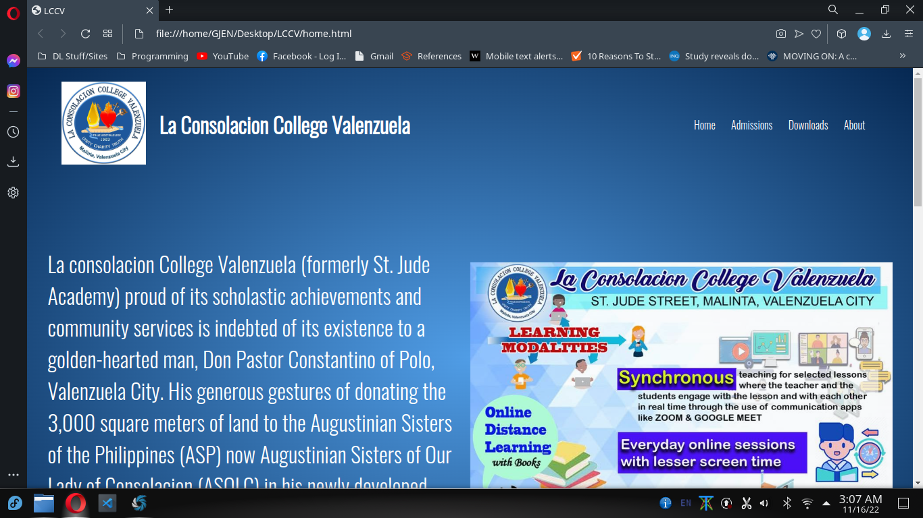The user will be greeted by a short message and a sideshow that showcases the school's programs or other marketing points

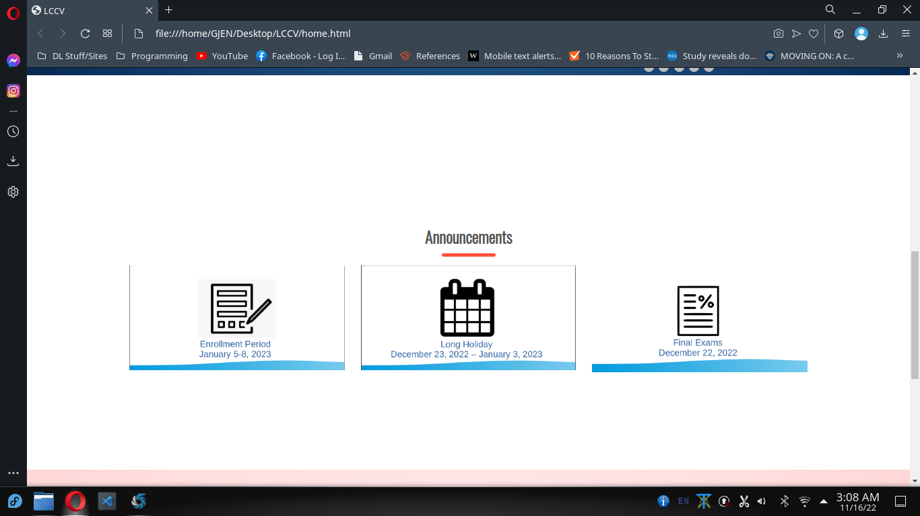Scrolling a bit further down the announcements will be seen

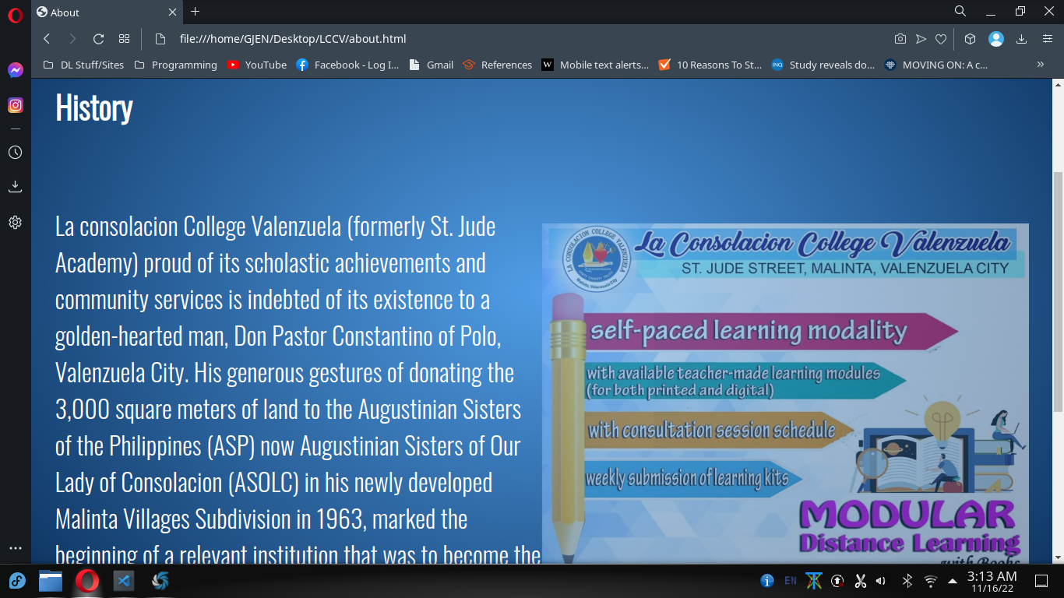The about tab shows the history of the institution

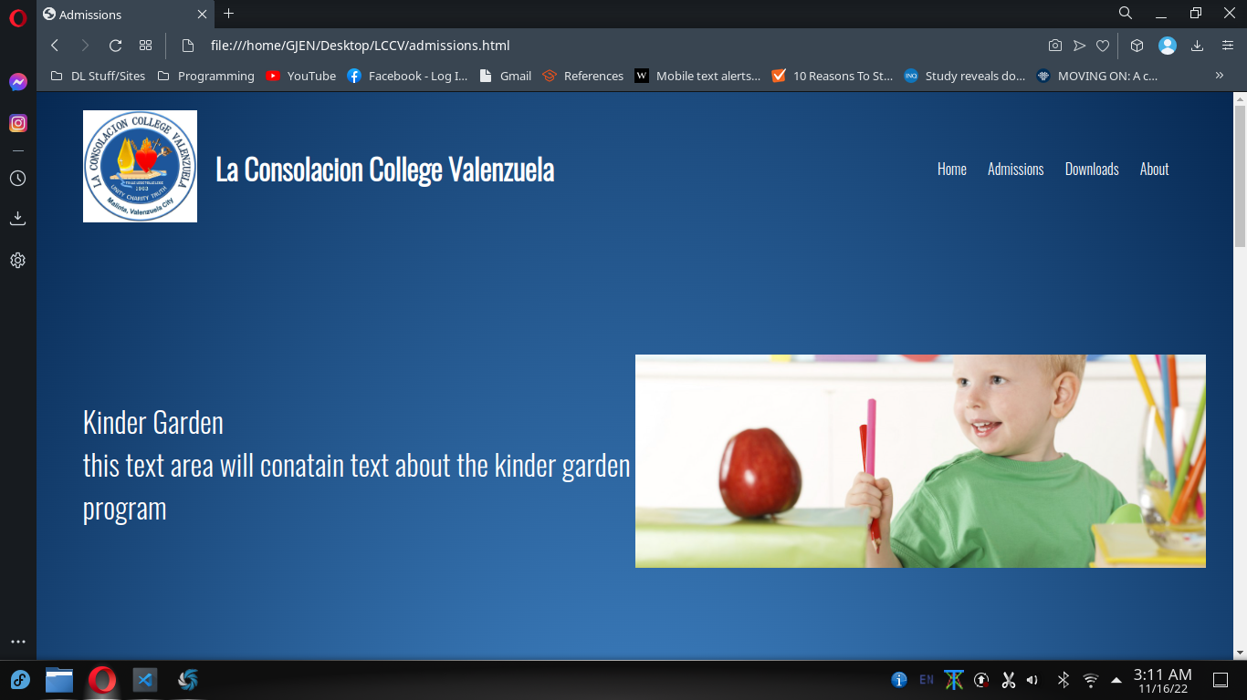The Admissions tabs shows available courses and what the program entails

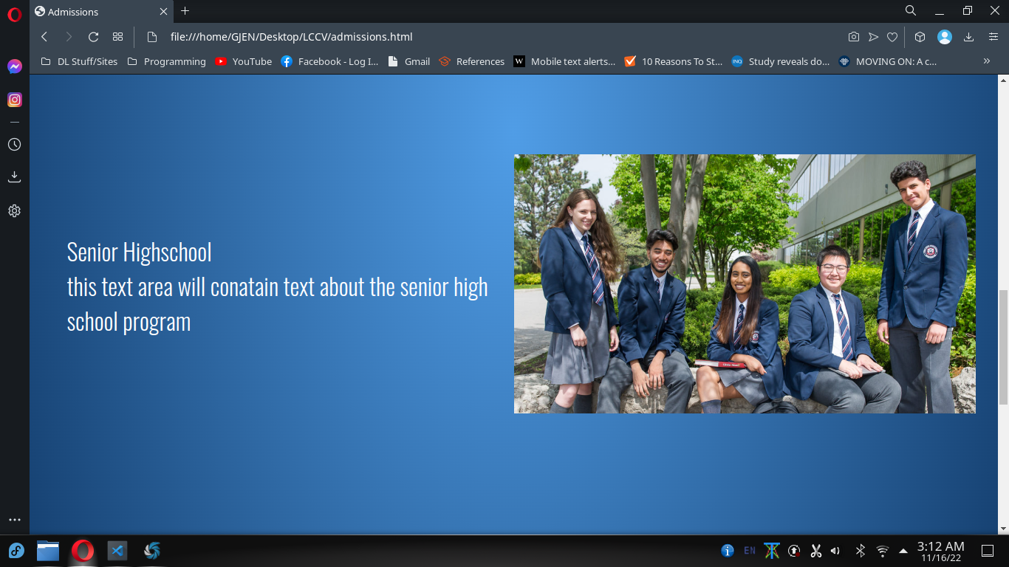

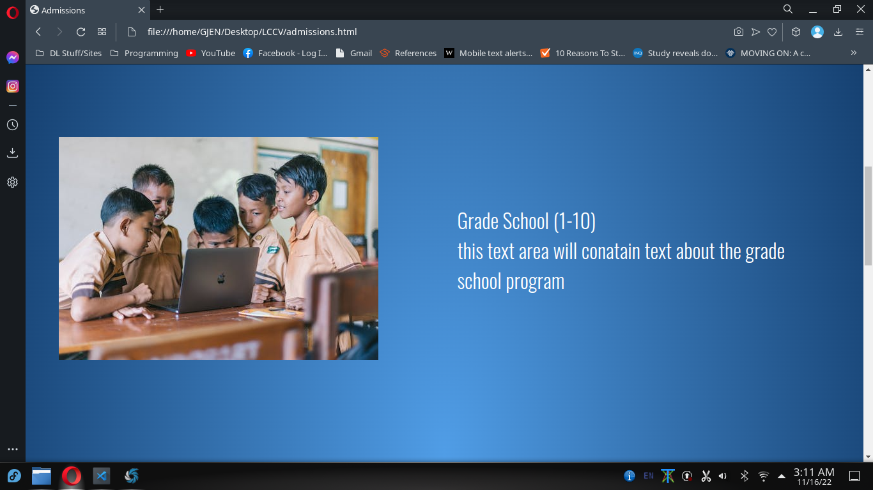

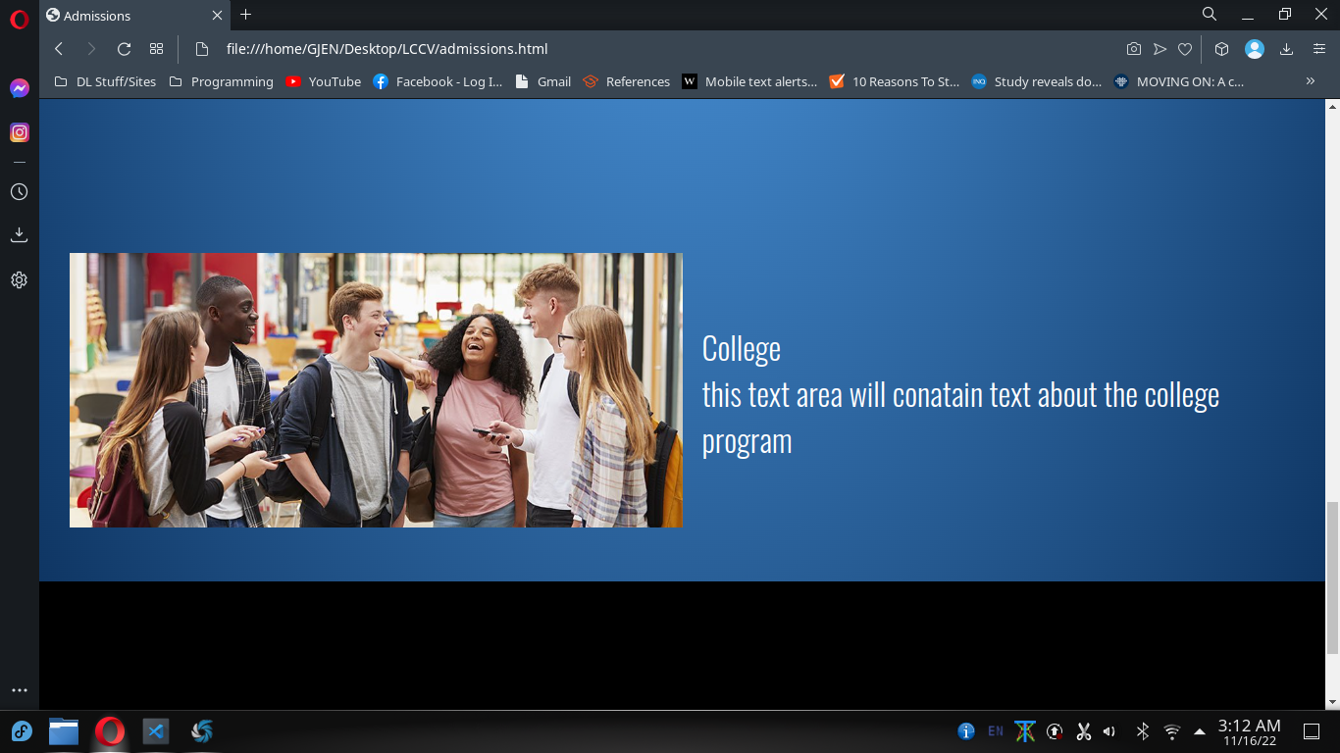  
  
  
  
  
  
  
  
  
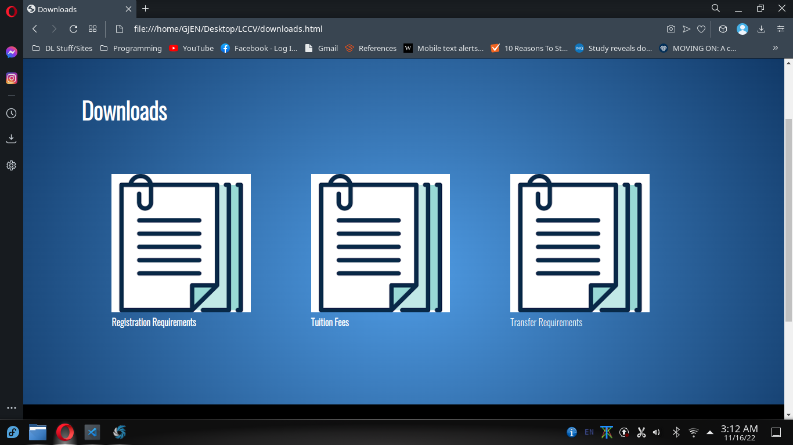  
  
  
  
The Downloads tab shows useful forms and pages that can be downloaded in pdf format for printing purposes